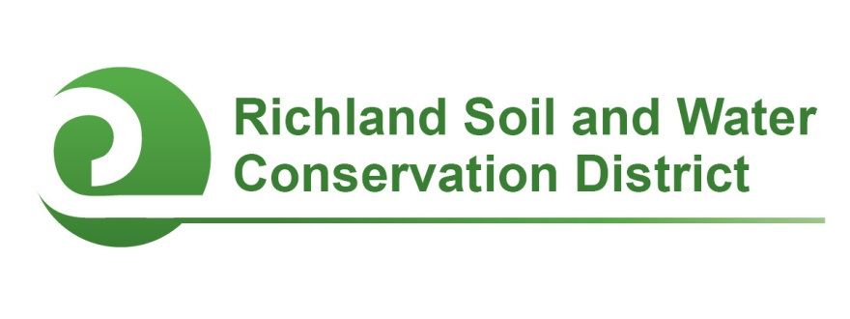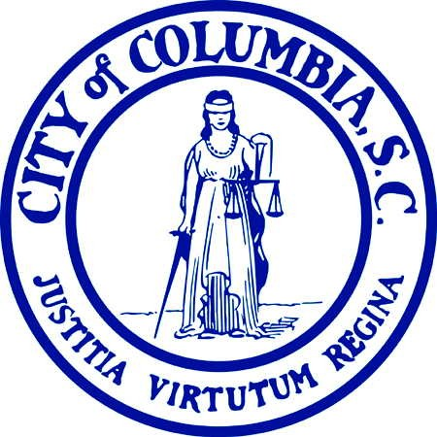
2017-2018 Conservation Education and Clean Stream Columbia
Mini-Grants

Columbia, SC—Faculty and staff members of public, private, and alternative schools in Richland County are eligible to apply for grants in the amounts of $500 or $1,000 to support campus conservation projects and youth environmental education initiatives through Conservation Education Mini-Grants and Clean Stream Columbia Awards.

All schools located in Richland County (including the City of Columbia) are eligible to compete for Conservation Education Mini-Grants. Mini-Grants may be used to support conservation-related student projects including, but not limited to, outdoor classrooms, school gardens, nature trails, wildlife habitats, rain barrels, composting initiatives, air quality campaigns, litter clean-ups, rain gardens, erosion control, and stream bank restoration. Awards are competitive and proposals will be evaluated on the project’s conservation impact, feasibility, student and community involvement, and educational outcomes. Three $500 mini-grants and one $1,000 mini-grant are available in each award cycle. Applicants should design a budget based on what is most appropriate for their project.

Additionally, schools located in the City of Columbia are eligible to compete for Clean Stream Columbia Awards. These awards provide funding for projects that promote, protect, or improve water quality such as rain gardens, rain barrels, erosion control, pet waste programs, stream monitoring, composting, etc. One $500 Clean Stream Award is available in each award cycle.

Two award cycles are available: applications received by September 29, 2017 will be considered for fall 2017 funding; applications received by February 2, 2018 will be considered for spring 2018 funding. Funding is issued as a reimbursement for project expenses. Project work and the expenditure of funds must be completed by June 15, 2018. Funding for these awards is provided by the Richland Soil and Water Conservation District and the City of Columbia. For more information, contact Chanda Cooper at (803) 576-2084 or cooperc@rcgov.us.
# # #
Conservation Districts are political subdivisions of state government under the local direction of five-member Boards of Commissioners. The Richland Soil and Water Conservation District promotes the wise use of natural resources for the benefit of the citizens of Richland County.

Contact
Richland Soil and Water Conservation District
2020 Hampton Street, Room 3063A
Columbia, SC 29204
Phone (803) 576-2080
Fax (803) 576-2088
E-mail soilandwater@rcgov.us
Facebook www.facebook.com/rswcd

2017-2018 Conservation Education and Clean Stream Columbia
Mini-Grant Application

Please respond to the following questions. Expand response areas and attach additional pages as necessary.

- Project Title:

- Applicant’s Name:

- Applicant’s Title/Position:

- Applicant’s E-mail:

- Applicant’s Phone:

- School:

- School Address:

- Principal’s Name:

- Principal’s E-mail:

- Describe the proposed project and how it will promote natural resource conservation and education.

- Is the school located in the City of Columbia?
___ Yes
___ No
*If you are unsure if your school is located in the city, visit http://gis.columbiasc.gov/cocinfo/ and enter the school’s street address in the search box on the right side of the page. If the address is located within the City limits, a “City Information” box in the lower left-hand corner will state “Am I within the City Limit? Yes.”

- Does the proposed project protect or improve water quality, reduce stormwater runoff or erosion, and/or promote water quality education?
___ Yes
___ No

- If you answered “yes” to question 12, explain how the project will protect or improve water quality, reduce stormwater runoff or erosion, and/or promote water quality education. (If you answered “no” to question 13, proceed to the next question.)

- I am applying for
___ $500
___ $1,000

- Project Budget:
Item | Unit Cost ($) | Quantity | Cost ($)
Total ($)
- Funding: If your project will cost more than $500 or $1000 (the maximum amount of the mini-grants), how will the rest of the project be funded?

- Project timeline: Describe your project’s timeline.

- Student Involvement:
  - How many students will be involved with this project? List by grade.
  - How will students be involved with this project?

- Collaboration: Describe if and how other faculty members, staff, parents, project mentors, or community volunteers will be involved with the project.

- Educational Outcomes: How will this project enhance student learning? If appropriate, include any state or local academic standards this project will be used to address.

- Optional Supporting Materials: You are welcome but not required to submit photographs with captions, letters of support, or other materials demonstrating why your project deserves to receive a Conservation Education Mini-Grant.

- Administrator certification: A school administrator (principal or headmaster) must certify that they agree to allow the proposed project to be completed or installed on campus. Please have your school administrator either sign on the line below OR submit a separate certification in writing (fax or e-mail is acceptable) acknowledging their support for this project.

_______________________________________________ _______________________
Principal’s Signature Date

Submit your application and any optional supporting materials by US Mail, E-mail, fax, or hand delivery to:

Richland Soil and Water Conservation District
2020 Hampton Street, Room 3063A
Columbia, SC 29204
Phone: (803) 576-2080
Fax: (803) 576-2088
E-mail: cooperc@rcgov.us

Application Deadlines:
September 29, 2017 and February 2, 2018

